Section 3 P1  
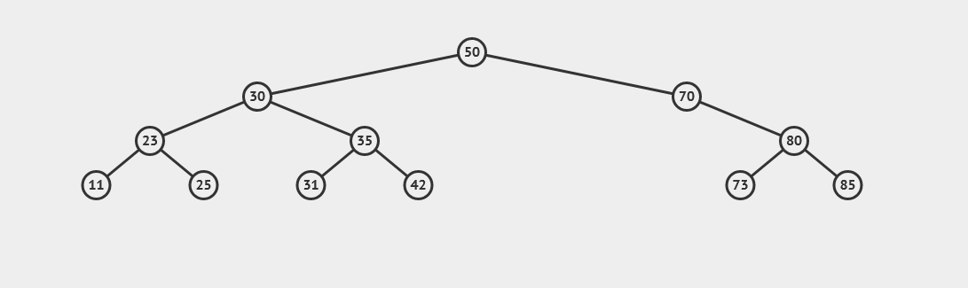We start the tree by adding (50,30,23,11,25,35,31,42,70,80,73,85) and we get the figure above.

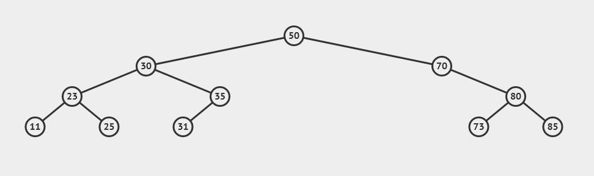When trying to delete 42 we do the following:  
 we search for 42 traversing the tree if the element is a leaf we DELETE directly if it has 1 child   
 we bypass and connect the parent with the child else replace the element with its successor  
 in this case it’s a leaf

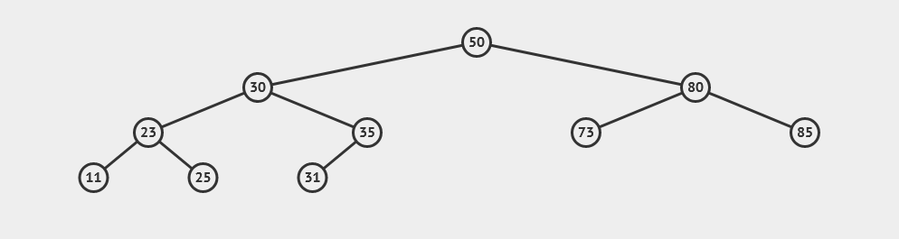When trying to Delete element 70 we bypass and connect the parent with the child because it has only one child which is element 80, so we connect its parent (50) with its child (80)

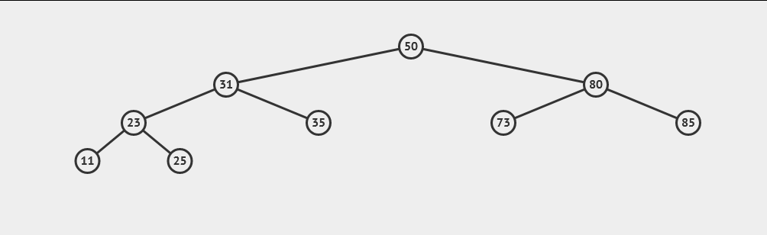When trying to delete element 30 we find out it has 2 children so we replace it with its successor and delete element 30, in this case its successor its element 31